In summary, computer architecture deals with the high-level design principles and conceptual structure of a computer system, while computer organization is focused on the implementation of that architecture design.

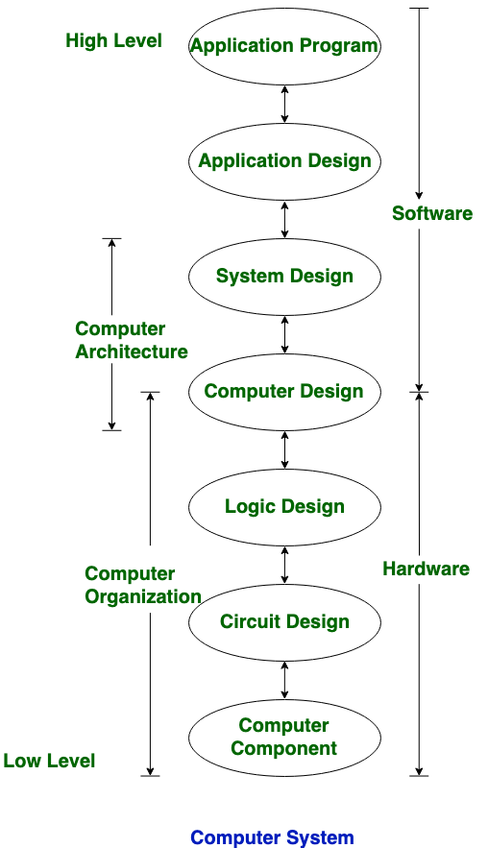

*Examples of architectural attributes include the instruction set, the number of bits used to represent various data types (e.g., numbers, characters), I/O mechanisms, and techniques for addressing memory. (visible to programmer & have a direct impact on the execution of a program.)*

*Organizational attributes include those hardware details transparent to the programmer, such as control signals; interfaces between the computer and peripherals; and the memory technology used.*